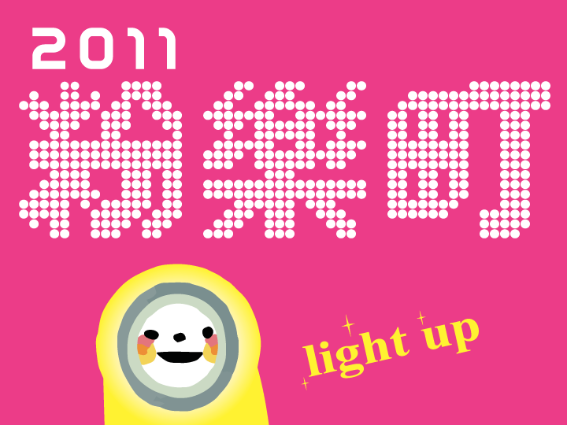

Very Fun Park 2011

Urban Contemporary Art Exhibition

Duration：July 23 (Sat), 2011 - September 30 (Fri), 2011
Venues：100 locations throughout Taipei’s East District

Organizer：
2F No. 258 Sec. 4 Ren-Ai Rd., Taipei City, Taiwan
www.fubonart.org.tw
Exhibition Department: +886 (0)2-2754-6655
Contact: Winnie Tsao (ext. 404)
Winnie@mail.fubonart.org.tw

What Is Very Fun Park?

"Very Fun Park" is an exhibition about diversity and creativity. The spirit of "Very Fun Park" is that an art exhibition doesn’t have to be exclusive to galleries or museums - fun corners in the city could be the fountains of creativity. Therefore, Very Fun Park takes contemporary art to the streets and make it part of urban landscape.

The very first edition of Very Fun Park, "Very Fun Park – An Exhibition of Taiwanese Contemporary Art," was co-organized by Fubon Art Foundation and the Hong Kong Arts Center in September 2000. It attracted 90,000 visitors during its first stop in Hong Kong. Humorously labeled as “Made in Taiwan and marketed in Hong Kong,” the exhibition built up a bridge to support cultural exchange in the Asia-Pacific region. It is also part of Fubon Art Foundation's proactive approach to promoting international cultural exchanges and giving young Taiwanese artists an opportunity to be seen on international stage.

When the Very Fun Park exhibition toured the Perth Institute of Contemporary Art (PICA) between March 14 and April 29, 2001, it garnered a great deal of local attention. It then returned to Taipei's East District, a very different space from Hong Kong's art-center exhibition venue and the restored-historic-building-turned-gallery in Australia. We switched our focus to local communities to seek out more alternative spaces within the lanes and alleyways of the East District (such as fashion boutiques, cafes, restaurants, community activity centers or even empty/abandoned houses). This was how the "Very Fun Park – An Exhibition of Contemporary Art in Taipei's East District" came to represent a completely different set of audience motives and interest than "Art Gallery – The Temple of Art."

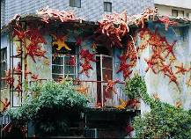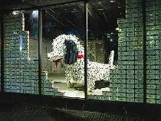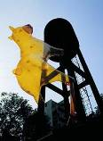

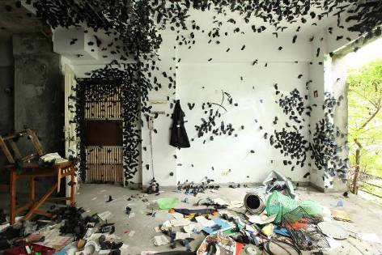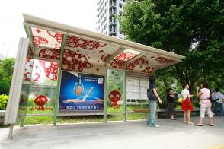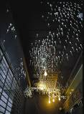

A Glorious Century of Art
Lighting up a world of wonder and joy
2011, marks not only the centennial of the Republic of China (ROC), but also the 50th anniversary of the establishment of the Fubon Group, making this a time of importance and celebration. As a member of the Fubon family, this is a moment of particular significance for the Fubon Art Foundation and to commemorate it we present 50 exhibition areas and 50 recommended stores stretching from Songshan cigarette factory to Xinyi District in the Eastern District of Taipei City. This exhibition is the largest for several years, the art on display representing 100 beacons scattered throughout the city, illuminating its true urban appeal.
In recent years “Very Fun Park” has become an increasingly well known part of the art world in Taipei and gone some way to dispelling the idea of art as something essentially separate from daily life. We very much believe that this is the perfect way to make art an integral part of life, because it infuses the city with vitality and allows us to wander through an intriguing mix of art works and urban space. One of the most enchanting things about “Very Fun Park” is that anyone in the city - office workers, tourists, residents – is liable to encounter art, exchanging spatial perceptions in the friendliest and most accommodating of ways. “Very Fun Park” displays art so that it is cherished and always the focus of attention. One of these works, displayed on the exterior of the Fubon Banking Center building, was created by Canadian artist Gordon Wiebe and sponsored by the Department of Cultural affairs. This piece presents a stunning combination of variegated colors and friendly smiling faces, the blossoming ground bloom flowers infusing Eastern Taipei with an attractive dash of colorful brilliance.
Life needs to be nourished by art. To have it is a blessing and to be able to share it with others is to spread love and warmth. Experience and emotionally moving viewers are the best way to grab their attention, removing the need for verbose explanations. With this exhibition, Fubon Art Foundation seeks to light up the moment and share art with everyone. Welcome to “Very Fun Park” a place of wonder and joy

Fubon Art Foundation CEO
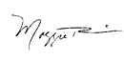

2011 Curatorial Concept: Light Up!
Very Fun Park 2011 (http://www.fubonart.org.tw/veryfunpark2011/index.html)

Light is a method of energy transmission. With the movement of waves or particles, light makes sight possible. Light allows us to see the world, appreciate the variety of nature and embrace the wonder of colors. Since the beginning of the history of art, light has always held a special place. Light allows us to see an object by not only revealing its existence but also its texture and depth. Light gives more vitality and expressiveness to color. What is more, the duality of light and shadow is a source of inspiration that leads us to cross over reality and an imaginary world. Light is an essential element in the art, a connection that brings creativity and the world together.

From a psychological prospective, light brings out a wealth of emotional energy within people. Different intensities and rhythms of light inspire different psychological reactions and feedbacks. After all, sunlight initiated life, and thus sunlight influences us, no matter how unaware we might be, on both physical and psychological levels. It has been proved that sunlight is beneficial for metabolism and some diseases; and indirectly, it affects our mood and inner strength.

The core focus of Very Fun Park has been on possibilities to combine art and urban lifestyle, with an emphasis on unexpected encounters in random streets or alleyways where travelers (or residents) wander, examine, discover and reminisce about. By introducing art to everyday life, a wonderful chemical reaction between daily consumption and aesthetics is triggered. In 2011, Very Fun Park is going to take “light” as the metaphorical medium to reach out and bring in the audience. As people stroll, sit or even casually lie down between streets and shops, their experiences with art will light up more exciting possibilities in the city even when the night falls.

2011 is the centennial of R.O.C (Taiwan). Apart from looking back on the national history, development and economic progress, we also believe that a-hundred-year experience accumulation is also a new starting point for the next century. This precious accumulation built up over time is also the guidance for the future while our hopes and pictures for tomorrow serve as spice of life. With the theme of "Light Up!", Very Fun Park 2011 seeks to light up daily life with some fun and surprising fuel and energy from art. No matter whether it is day or night, with a cheerful and bright attitude, we look forward to embracing life and striding towards the next one hundred years.
Participating Artists:
52 local and international contemporary artists take part in the exhibition this year.
Liesbet Bussche, Chang En-tzu, Chang Huei-Ming and Liao Chi-Yu, Chang Teng-Yuan, Chen Shu-Chiang, Chen Sung-Chih, Chen Wan-Jen, Chen Yi-Chang, Owen Chuang and Cloud Lu, Fang Minto, Katsumi Hayakawa, Hsu Min-Sheng, Hu Ta-Hua, Hu Hwei-Jing, Hsieh Jia-Wen, Hsin-Chien Huang, Jasper Huang, Huang Hsin-Yu, Takashi Iwasaki, Ta-Hsien Jen, Haru Komoda, Pojui Lin, Tai Hsuan Lin, Lin Yu-Ting, Liu Ding-Zan, Liu Po-Chun, Lu Chih-Yun, Lu Yen-Yu, Luo Jr Shin, Yuki Matsueda, Mr. A-Lei, Ena Nagao, Shinji Ohmaki, Pan Xin-Quan, Sheu Jer Yu, Leonid Tishkov, Tsai Hsiao-Chi and Yoshikawa Kimiya, Page Tsou, YungYen Tsui, Tsui Hui Yu, Fujui Wang, Yujuin Wang and Tong Yali, Gordon Wiebe, Wu Chi-Tsung, Wu Chi-zeng, Yang Pei-Chen, Sophie Yu, Kijong Zin

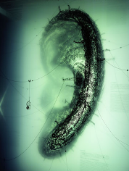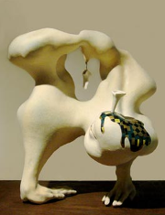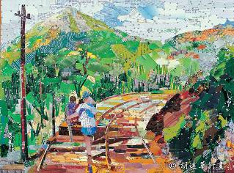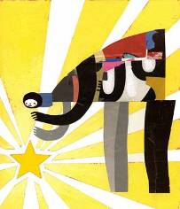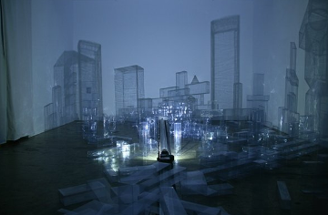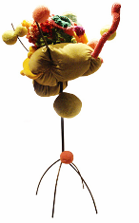
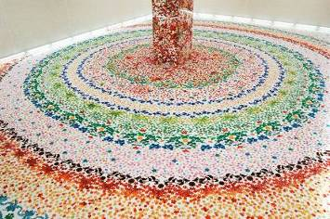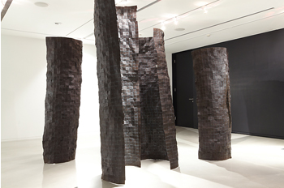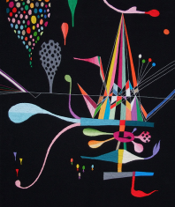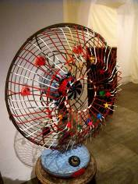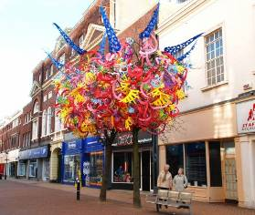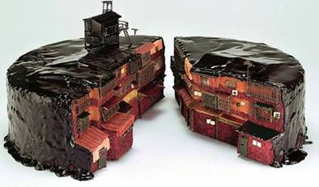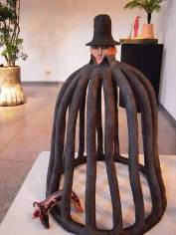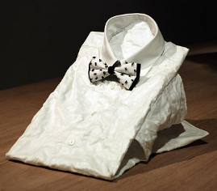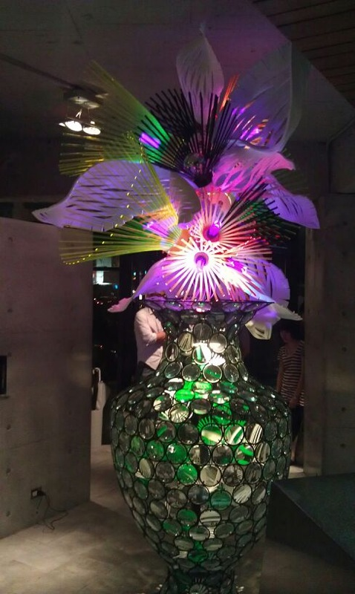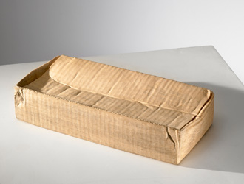
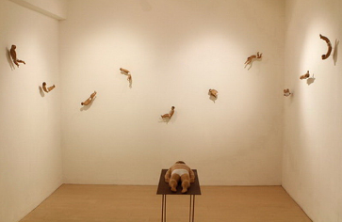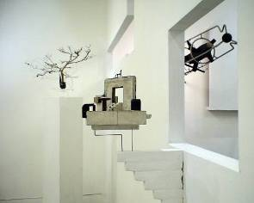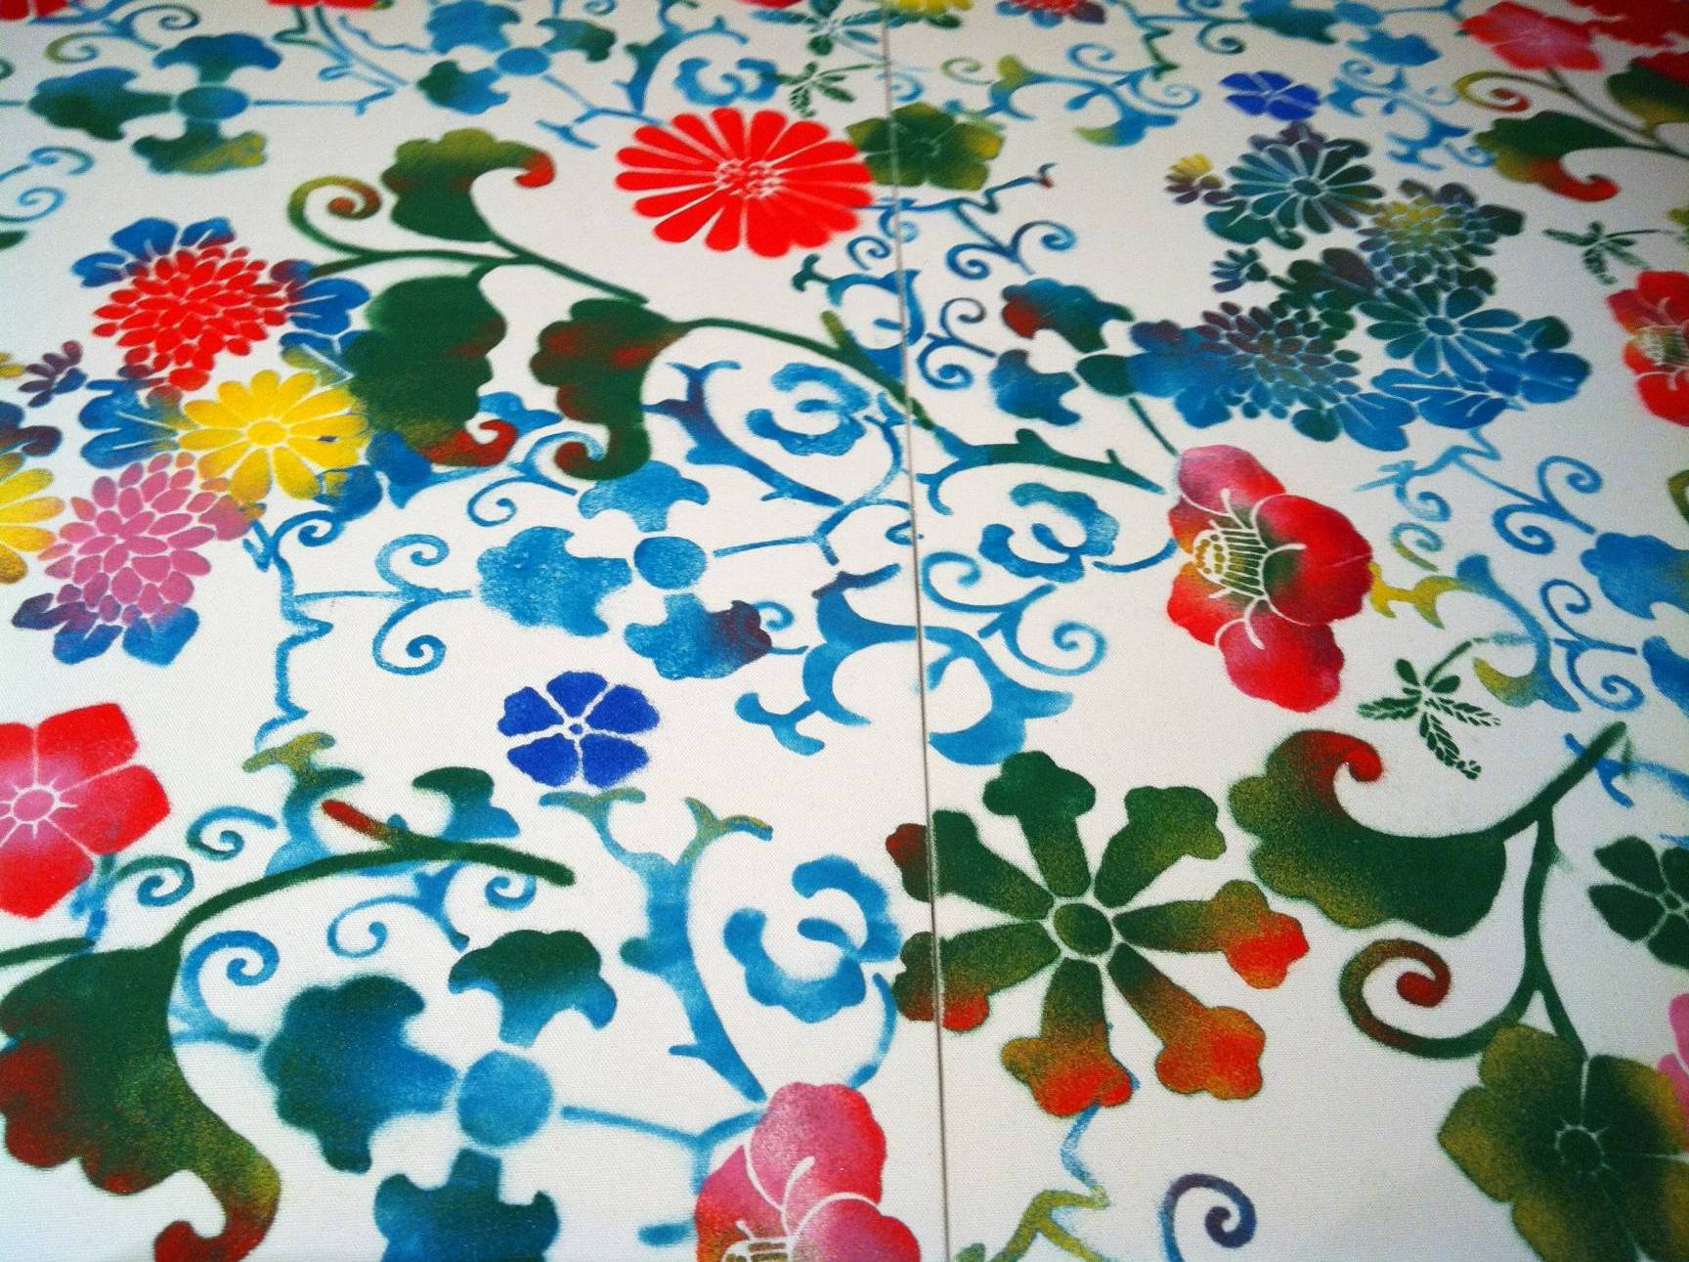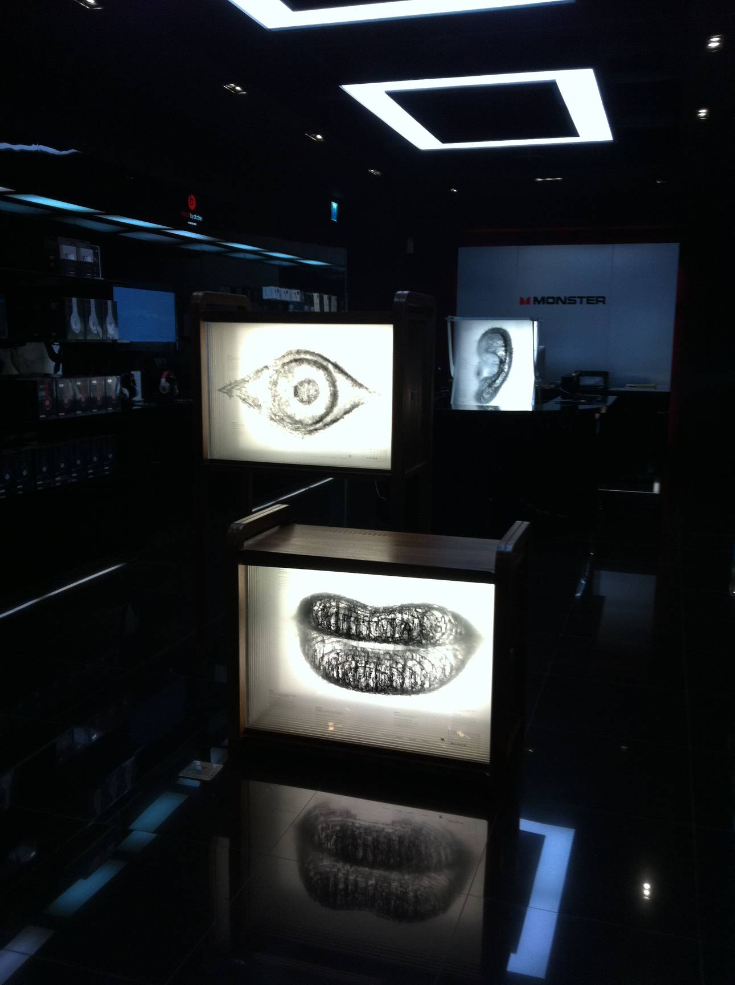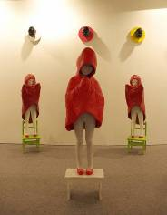
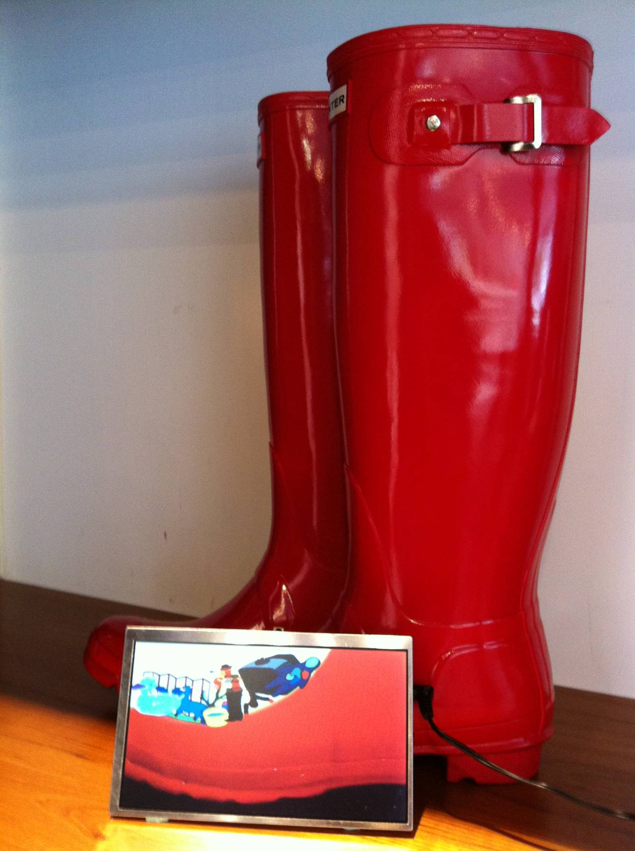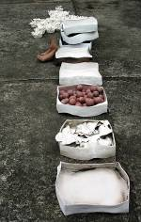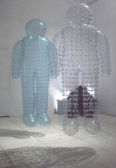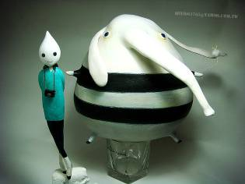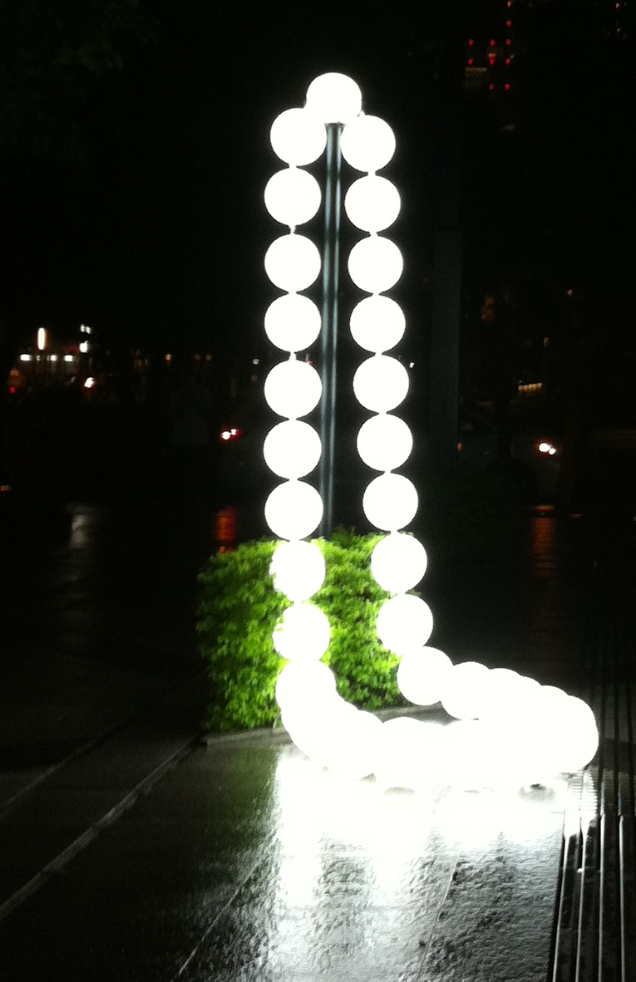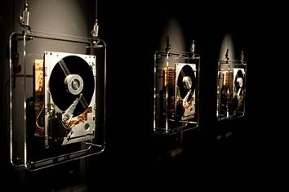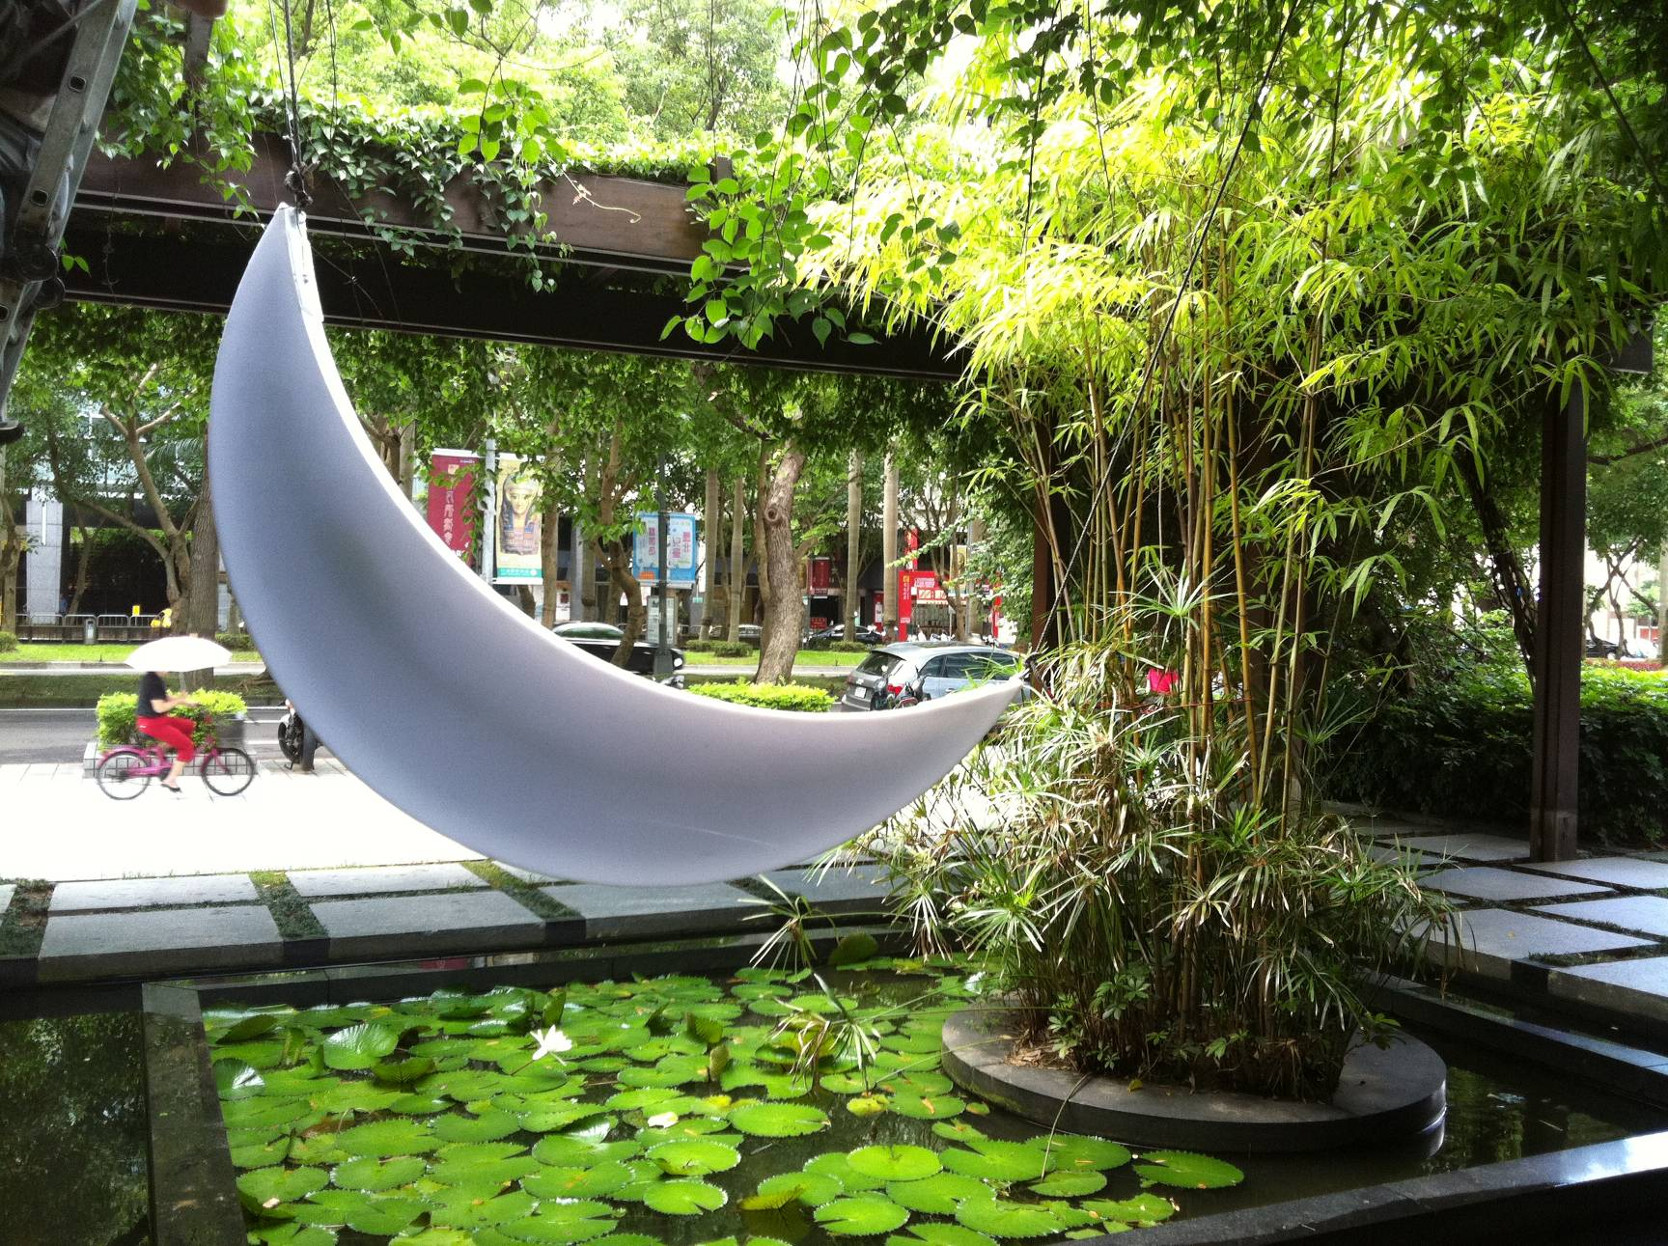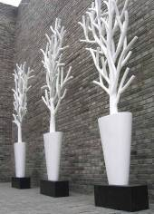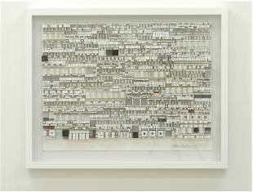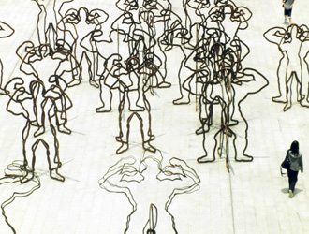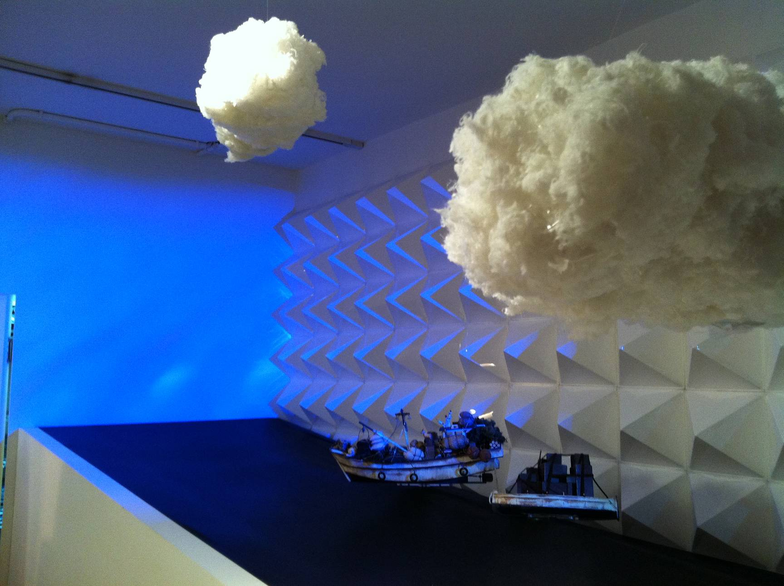

Venues:
Mapped out around the cross between Sec. 4 Zhongxiao E. Rd. and Sec. 1 Dunhua S. Rd., Taipei’s East District is the heartland of Very Fun Park, with an extension to Xinyi District, an emerging commerce district of Taipei. This year, Very Fun Park 2011 also expands its exhibition further east to include Songshan Tobacco Factory, a historic structure turned cultural complex. With the concept of a wall-less museum, Very Fun Park aims to closely integrate with Taipei’s tourism, culture, and creativity, bringing out the city’s character and vitality.

Venue Examples:
Shops in East Taipei alleys: fashion boutiques, restaurants, hair salons, pet stores, shops for designer goods, music studios, book stores, flower shops, local activity centers, private spaces, etc.
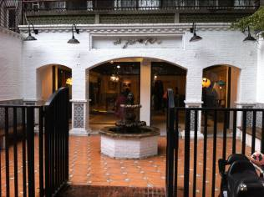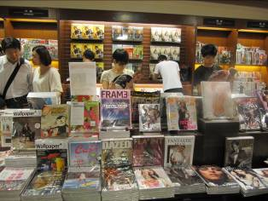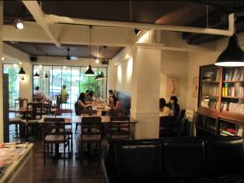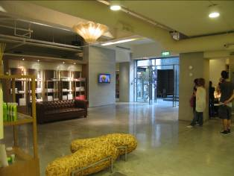
Fubon Group: Fubon Life Insurance, Financial Building, Construction Site includes rear of SOGO Zhongxiao, and Citizen Boulevard/Dunhua intersection.
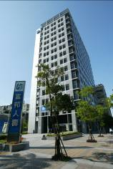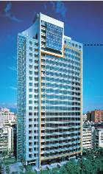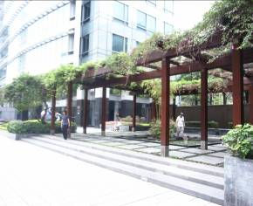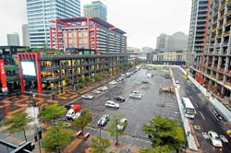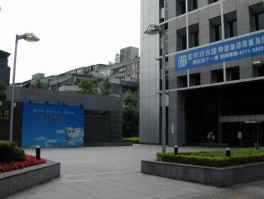
Support from Department of Urban Development and Cultural Affairs Bureau: shade trees on the streets, sidewalks, public squares, metro stations, and shelters at bus stop.
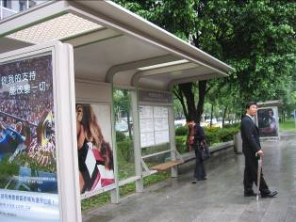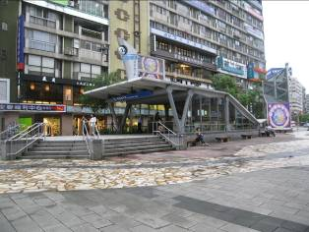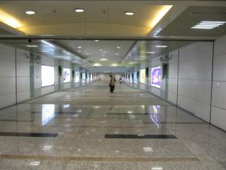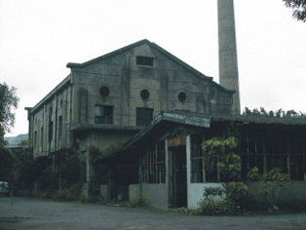
Inter-Industry Cooperation: Eslite Bookstore, Home Hotel, etc.
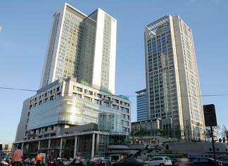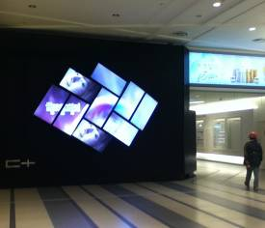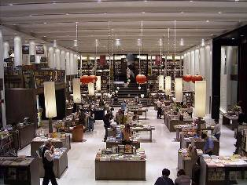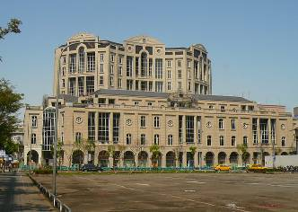

Venues
